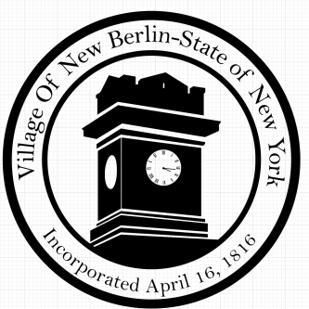Village of New Berlin

13 South Main Street

New Berlin NY 13411

**Maintenance/Issue Resolution Request Form**

Please use this form to notify the village of a Village maintenance issue request. Mail or drop off this form to the Village of New Berlin Office.

Date:

Location of Maintenance Issue:

Description of Maintenance Issue:

Name:

Address:

Phone Number:

Email:

**Office Use Only**

Date Received: _______________

Department:

DPW _____ Code Enforcement _____ Building & Grounds _____ Board Member ______ Other___________

Priority Level: 1 2 3

Completed: _______________